Table of Contents
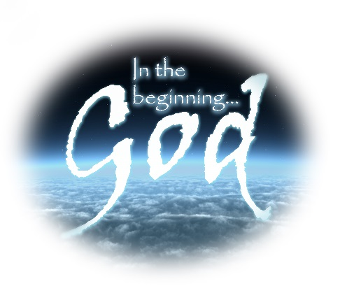
- Preface – Seeing the Attributes of God in Other Ways
In the Beginning – God
A lesson series from the books of Moses considering the attributes and personality of God, especially as He progressively revealed Himself to mankind through His creation, His judgments, and His work of redemption.

- Lesson # 1 – Introductory Thoughts – Can We Know God? - Creation
- Lesson # 2 – Divine Transcendence & Eternality - His Sovereign Plan
- Lesson # 3 – Divine Holiness – Justice and Judgment – The Flood
- Lesson # 4 – Divine Mercy – Covenants and The Call of Abraham
- Lesson # 5 – Divine Faithfulness – Preservation of the Promised Seed
- Lesson # 6 – Divine Grace – The Life of Joseph
- Lesson # 7 – Divine Redemption – Exodus and the Passover
- Lesson # 8 – Divine Approachability – Levitical Priesthood and Offerings
- Lesson # 9 – Divine Chastisement – Numbers - The Wilderness Wanderings
- Lesson # 10 – Divine Restoration – Deuteronomy - The New Generation
- Conclusions

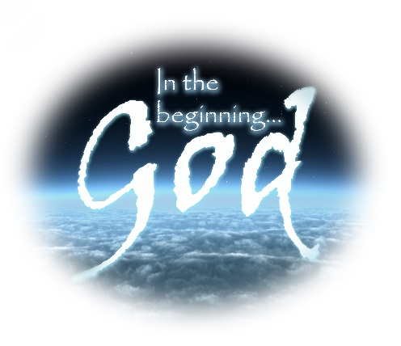
Preface: Seeing the Attributes of God in Other Places
When we set out to learn the attributes of God as they are revealed to us in the Scriptures we recognize that we could study God’s character from any number of places. Our lesson series focuses on learning from the Pentateuch, but just for a moment, reflect on other portions of Scripture that would be equally productive!

Example # 1 When Jesus Christ came to the earth as God incarnate
What attributes of God come to mind when you consider:
- He came supernaturally – born of a virgin.
- He came in God’s pre-determined time. (Gal 4)
- He had compassion on the widow of Nain, raised her son.
- He healed lepers, fed the 5,000.
- He praised the widow who cast in her 2 mites.
- He chased the money changers out of the temple.
- He rebuked the Scribes and Pharisees, the publican went down to his house justified.
- He had power over Satan, cast out demons.
- He never sinned – but lived a perfect example.
- He revealed many things about the future. (Matt 24-25)
- He laid down His life willingly for our redemption.
- He became a high priest who is touched with the feelings of our infirmities.

Example # 2 From the Book of Revelation
What attributes of God come to mind when you consider:
- God revealed what would happen in the end times through John.
- Revelation describes the throne and dwelling place of God (chapter 4)
- Revelation shows the titanic struggle between the righteous and the wicked, between God and Satan.
- The nations array against Israel, but God delivers her.
- Ultimately God has His way in the tribulation (fulfills His purpose for Israel and the Gentile nations) with the various seal, bowl, vial judgments.
- God mercifully sends the chosen 144,000 and the two witnesses. (Ch 14)
- The Lord establishes the kingdom age and the earth has 1,000 year peace
- There is a great white throne of judgment
- The existence of the Lake of Fire.
- God superintends the circumstances that lead to the ultimate end of Satan.
- God creates a New Heaven and the New Earth.
- God’s invitation is extended again Rev 22 – “the Spirit and the Bride say come.”
- He promised to come, and also said, “I come quickly.”

